eCommerce Analytics Training
2026
Vaishnavi Kamthe

Assignment 1B.6
Tasks:

Step 1
Load the dataset for any one month and identify:
Dataset : Feb 2020
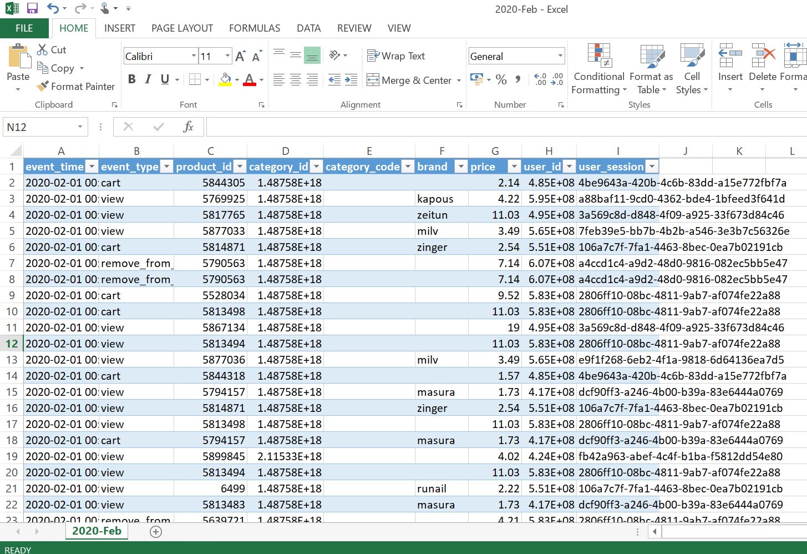
Couldn't use excel as mine is an older version and it does not support these many rows.
  - Total number of unique customers - 6932
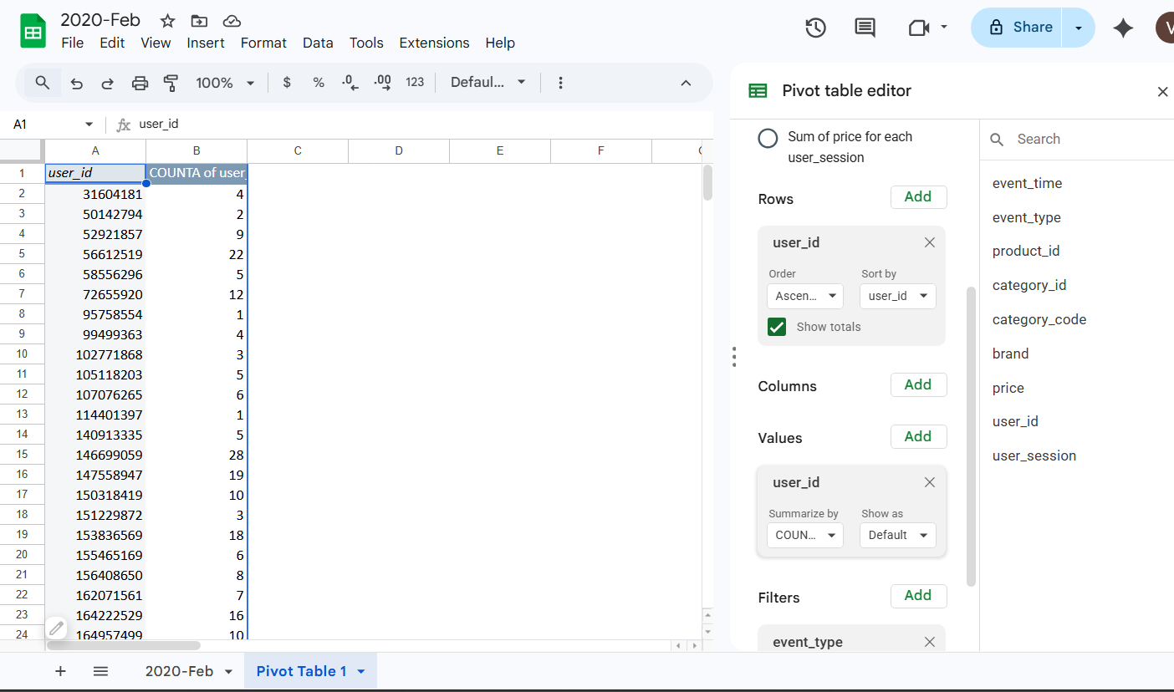
  - Total number of orders - 7301
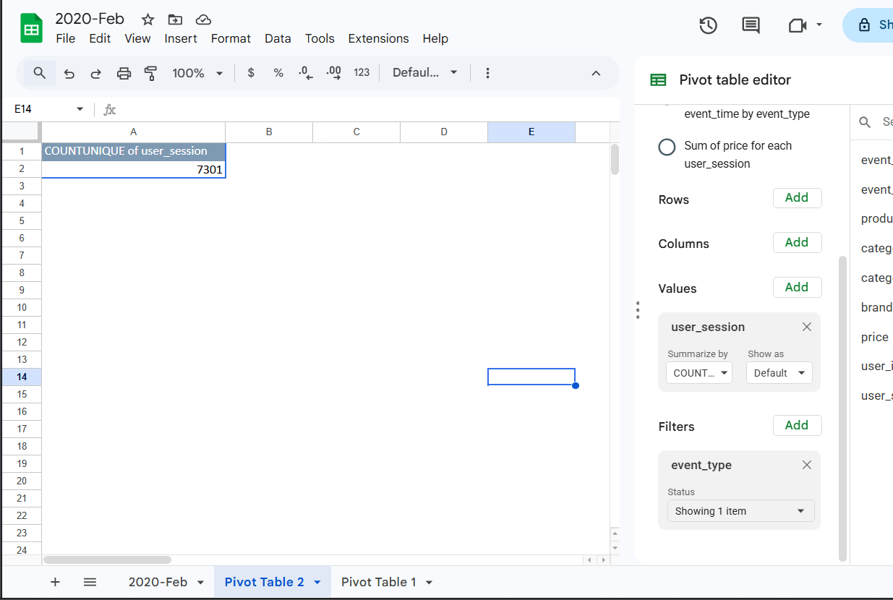
  - Average cart size (number of items per transaction) - 8.187782496
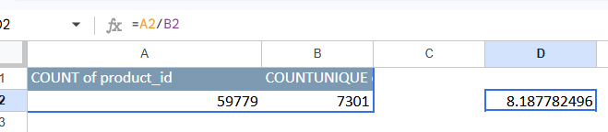

Step 2
Using basic Excel or Google Sheets:
  - Filter to only show purchase events
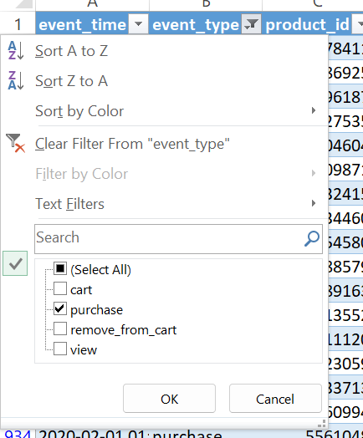
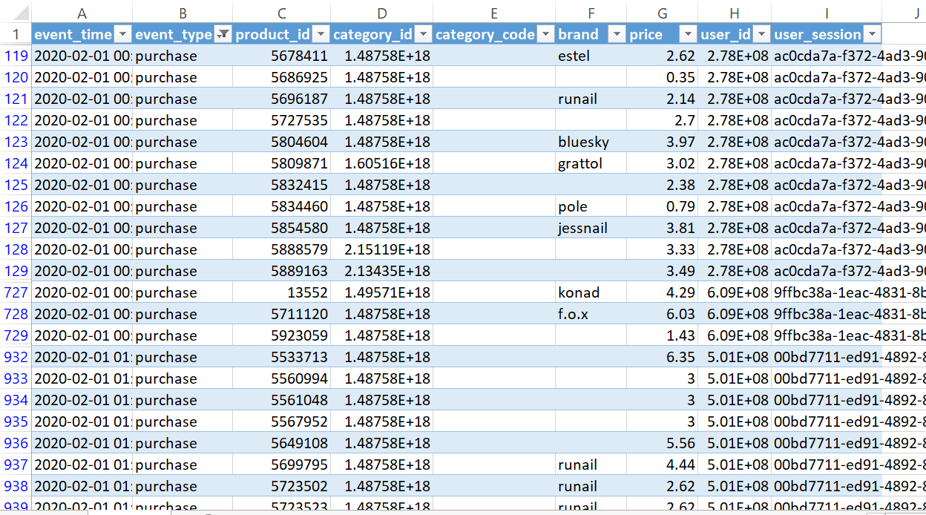
  - Find the most purchased product
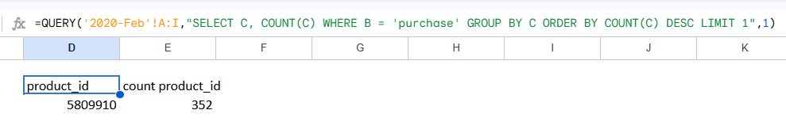
Bonus: Count how many orders came from mobile vs desktop (based on event or device column if present).
The dataset does not contain any device-related fields such as mobile or desktop indicators. Therefore, it is not possible to perform device-based analysis for order distribution.

